|  |  |  |
| --- | --- | --- |
| VILNIAUS KOLEGIJA  UNIVERSITY OF APPLIED SCIENCES  FACULTY OF ELECTRONICS AND INFORMATICS  https://screenshotscdn.firefoxusercontent.com/images/eaf3f7f3-2952-4801-af5c-4f20e8ae8b88.png | | |
|  | | |
| **INVESTIGATION OF RS422/RS485 SERIAL INTERFACE** | | |
|  | | |
|  | | |
| LABORATORY WORK  6531BX028 PI18E | | |
| STUDENTS | (SIGNATURE) | EDITA KOMAROVA    U**Ğ**UR FIRAT  DŽIUGAS PEČIULEVIČIUS |
| 2020-02 |
| (SIGNATURE) |
| 2020-02 |
| (SIGNATURE) |
| 2020-02 |
| (SIGNATURE) |
| LECTURER | 2020-02 | MARTYNAS ŠAPUROV | |
|  |  |  |
|  |  |  |

# OBJECTIVE

Our objective to understand how a differential interface works. To investigate the RS422/RS485 data interface methods, identify their maximum communication.

# ANALYSIS OF RS422 INTERFACE

We used Hyperlink Terminal to measure the transfer time of RS422

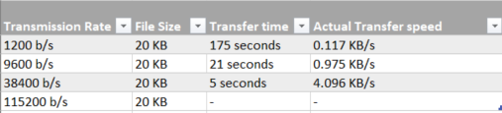

Figure 1- Analysis of RS422 interface

# ANALYSIS OF RS485 INTERFACE

The transfer time between RS422 transmission rate of 1200b/s is slower than in RS485.

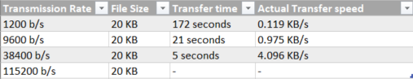

Figure 2- Analysis of RS485 interface

# RS485 WAVE FORM AND SIGNAL DAMPENING ANALYSIS

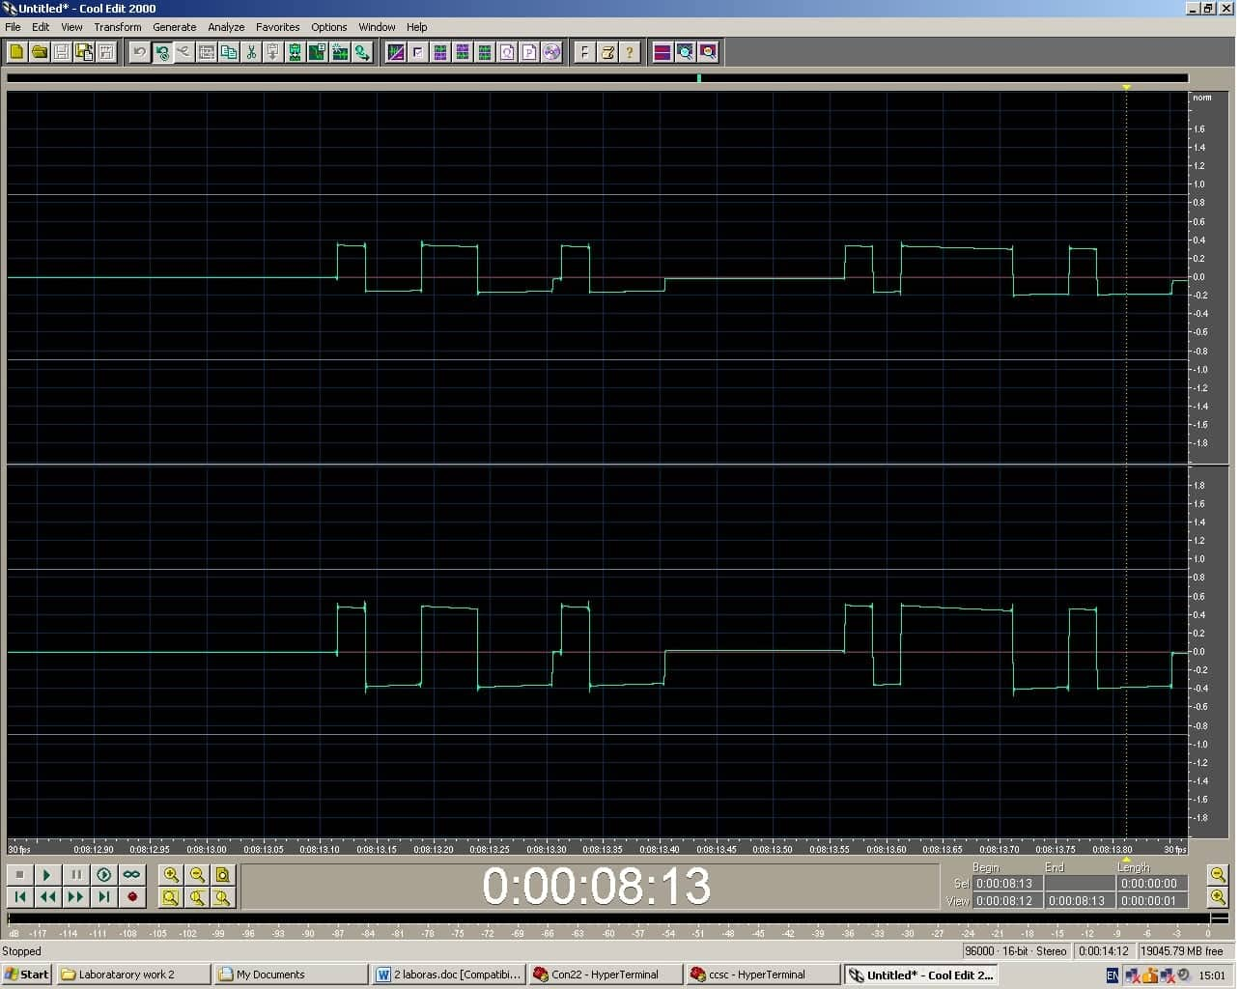

Figure 3- Wave form and signal dampening analysis

# GENERAL CONCLUSION

As for the conclusions, both RS422 and RS485 have similar transfer times depending on the transmission rate just RS485 is slower by 3 seconds than RS422 when transmission rate is set to 1200b/s. The higher the transmission rate is, the faster actual transfer speed is. While doing the signal suppression test no difference in speed has been notices between line lenght of 200m to 1200m. It stopped working and did not display any results when we exceeded the 1200 meter line limit.

# ANSWERS TO REVIEW QUESTIONS AND TASKS

1. **Explain the differential data exchange principle.**

What both RS422 and RS485 buses standards have in common that they both use hardware **differential signaling techniques** to allow a *combination of high speed communication over long distances who ground potential differences can be non-zero*. However, from a communication direction point of view, RS422 is not compatible with RS485, but RS485 can be made compatible with RS422.

1. **List the differential data transmission methods and their advantages and disadvantages.**

**Single-Ended** and **Differential Signaling**.

**Single-Ended signaling** is a simple and common way of transmitting an electrical signal from a sender to a receiver. The electrical signal is transmitted by a voltage (often a varying voltage), which is referenced to a fixed potential, usually a 0 V node referred to as “ground”.

One conductor carries the signal and one conductor carries the common reference potential. The current associated with the signal travels from a sender to receiver and returns to the power supply through the ground connection. If multiple signals are transmitted, the circuit will require one conductor for each signal plus one shared ground connection. Thus, for example, 16 signals can be transmitted using 17 conductors.

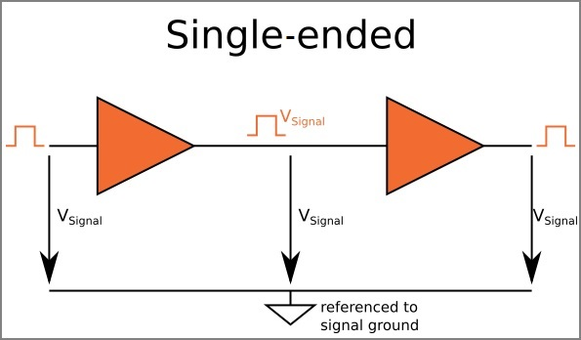

**Differential Signaling** which is less common than single-ended signaling, employs two complementary voltage signals in order to transmit one information signal. So one information signal requires a pair of conductors. One carries the signal and other carries the inverted signal. 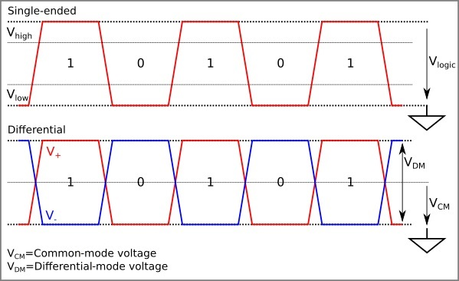

1. **Why twisted pair cables are more resistant to interference?**

Twisting the cables is done to remove the electromagnetic interference from the wires. When a signal is transmitted through the cable it is in the form of current. This flow of current produces a electromagnetic field of interference around it and can generate noise effects in the surrounding cables.

1. **Give a wired communication line equivalent scheme and explain the meaning of its elements.**

Communication distance is limited not only by external interference, but also by cable and wire parameters. Common two-wire communications line equivalent diagram is shown in picture below. Equivalent line chart consists of the distributed inductance L, resistance R, indicating resistive line impedance, the distributed capacity C and conductivity G, indicating the line losses. These elements depend on the length and therefore are marked by the nominal value of the element per unit length

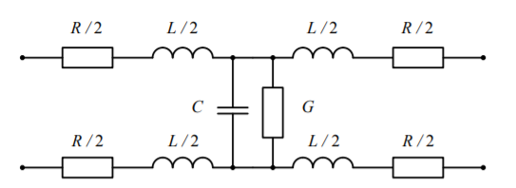

During asymmetric exchange, one of two-wire line conductors are connected to the ground and the R and L parameters can be ignored. Then we analyze the communication line equivalent scheme shown in picture below.

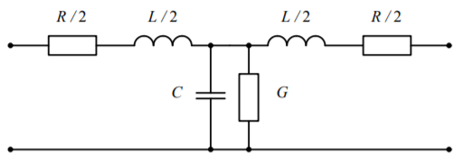

1. **Explain the RS422/RS485 interface operation, and name their main differences.**

Both are differential interfaces, which are widely used in industrial automation, security and fire alarm systems. RS422 is full duplex interface. The data is transmitted and received using separate wire pairs, i.e. to connect two devices a four wire connection cable is needed. RS485 uses half-duplex mode. The data transmission and reception takes place at different points in time using one wire pair.

1. **Give and explain the RS422 and RS485 bus schemes.**

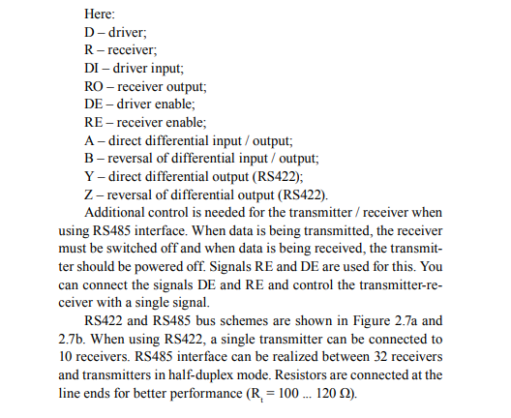

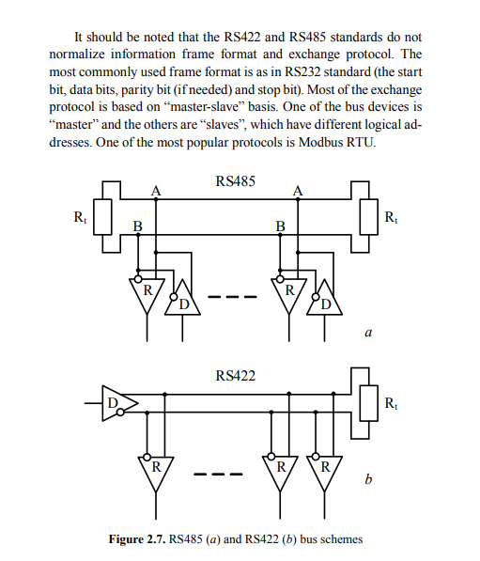

1. **List the main RS422 and RS485 interface parameters.**

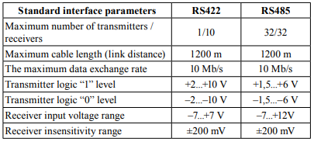

1. **Do RS422 and RS485 standards provide a possibility to identify peripheral devices on their bus?**

When data is being transmitted, the receiver must be switched off and when data is being received, the transmitter should be powered off. Signals RE and DE are used for this. You can connect the signals DE and RE and control the transmitter-receiver with a single signal.

1. **What may be the maximum number of peripheral devices in RS422 and RS485 bus?**

When using RS422, a single transmitter can be connected to 10 receivers. RS485 interface can be realized between 32 receivers and transmitters in half-duplex mode.

1. **How the reception and transmission mode switching is controlled in RS485 interface?**

# To use the RS-485 interface it is necessary to connect additional UART interface chip (e.g. MAX3430) converting the signal the signal of UART port into a signal of RS-485 interface. The technology uses a RS-485 bi-directional two-wire line, therefore the control outputs for enable/disable transmission/reception are needed for distinguishing between the processes of reception and transmission in interface chips. External control signal should be generated by a control device. Such signal can be generated by the microcontroller AT91SAM7S256, because it contains the hardware driver of RS-485 interface. Using ETRX2 and BLE-112 having no hardware driver leads to the appearance of the echo signal at the receiving side, which requires software filtering or received messages. You should take into account this feature when you are writing the program of processing of the received message